**Name: Sneha Roy , Section : B , Roll : 42**

**Enrollment No.: 12024006015099**

**Assignment - 3**

1. Write a program to store marks for n number of student in an array and print their marks.

**Answer:**

#include<stdio.h>

int main(){

  int arr[100];

  int n;

  printf("Enter total number of students : ");

  scanf("%d",&n);

  printf("Enter marks of each student : \n");

  for (int i = 0; i < n; i++)

    scanf("%d", &arr[i]);

  printf("\nEntered marks are : \n");

  for (int i = 0; i < n; i++)

    printf("Student %d  => %d \n", i + 1, arr[i]);

  return 0;

}

**Output:**

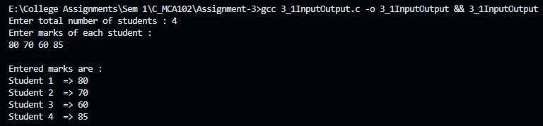

2. Write a program that stores the marks of the subject Mathematics and English of n number of students in an array and then prints their total marks.

**Answer:**

#include <stdio.h>

int main() {

  int n;

  printf("Enter the number of students: ");

  scanf("%d", &n);

  int mathMarks[n];

  int englishMarks[n];

  int totalMarks[n];

  // Input marks for each student

  for (int i = 0; i < n; i++) {

      printf("Enter marks for Student %d\n", i + 1);

      printf("Mathematics: ");

      scanf("%d", &mathMarks[i]);

      printf("English: ");

      scanf("%d", &englishMarks[i]);

      totalMarks[i] = mathMarks[i] + englishMarks[i];

  }

  // Print total marks for each student

  printf("\nTotal Marks of Students:\n");

  for (int i = 0; i < n; i++) {

      printf("Student %d: %d\n", i + 1, totalMarks[i]);

  }

  return 0;

}

**Output:**

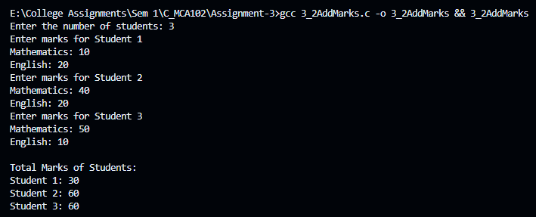

3. Write a program to insert an element in an array in a particular position.

**Answer:**

#include <stdio.h>

int main(){

  int arr[100];

  int n;

  printf("Enter the size of array : ");

  scanf("%d", &n);

  int position, element;

  printf("Enter elements for the array : ");

  for(int i = 0; i < n; i++)

    scanf("%d", &arr[i]);

  printf("Enter the position to insert the new element (0 to %d): ", n);

  scanf("%d", &position);

  if (position < 0 || position > n)

    printf("Invalid position! Please enter a position between 0 and %d.\n", n);

  else {

    printf("Enter the element to be inserted: ");

    scanf("%d", &element);

    n++;

    for(int i = n; i > position; i--)

      arr[i] = arr[i - 1];

    arr[position] = element;

    printf("Array after insertion:\n");

    for (int i = 0; i < n; i++) {

        printf("%d ", arr[i]);

    }

  }

  return 0;

}

**Output:**

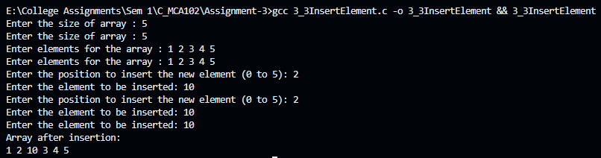

4. Write a program to delete an element from a particular position of an array.

**Answer:**

#include <stdio.h>

int main(){

  int arr[100];

  int n;

  printf("Enter the size of array : ");

  scanf("%d", &n);

  int position;

  printf("Enter elements for the array : ");

  for(int i = 0; i < n; i++)

    scanf("%d", &arr[i]);

  printf("Enter the position to delete (0 to %d): ", n-1);

  scanf("%d", &position);

  if (position < 0 || position >= n)

    printf("Invalid position! Please enter a position between 0 and %d.\n", n);

  else {

    for(int i = position; i < n - 1; i++)

      arr[i] = arr[i + 1];

    n--;

    printf("Array after deletion :\n");

    for (int i = 0; i < n; i++)

      printf("%d ", arr[i]);

  }

  return 0;

}

**Output:**

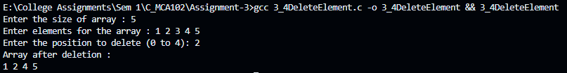

5. Write a program to convert a decimal number taken as input from a user to the corresponding binary number and store the result in an array.

**Answer:**

#include <stdio.h>

int noOfDigit(int n){

  int count = 0;

  while(n){

    count++;

    n /= 2;

  }

  return count;

}

int main(){

  int n;

  printf("Enter a number : ");

  scanf("%d", &n);

  int arrSize = noOfDigit(n);

  int arr[arrSize], i = arrSize - 1;

  while(n){

    arr[i] = n % 2;

    n /= 2;

    i--;

  }

  for (int i = 0; i < arrSize; i++) printf("%d", arr[i]);

  return 0;

}

**Output:**



6. Write a program to input a binary number in an array and convert it into a corresponding decimal number.

**Answer:**

#include <stdio.h>

#include<string.h>

int binaryToDecimal(int arr[], int n){

  int ans = 0;

  for(int i = 0; i < n; i++){

    ans = ans * 2 + arr[i];

  }

  return ans;

}

int noOfDigit(int n){

  int count = 0;

  while(n){

    count++;

    n /= 2;

  }

  return count;

}

int main(){

  char str[33];

  printf("Enter a binary number : ");

  scanf("%s", str);

  int n = strlen(str), arr[n];

  for(int i = 0; i < n; i++){

      arr[i] = str[i] - '0';

  }

  int ans = binaryToDecimal(arr, n);

  printf("Answer :  %d", ans);

  return 0;

}

**Output:**



7. Write a program to find the smallest and the largest elements in an array.

**Answer:**

#include <stdio.h>

int smallest(int arr[], int n){

  int min = arr[0];

  for(int i = 1; i < n; i++){

    if(arr[i] < min) min = arr[i];

  }

  return min;

}

int largest(int arr[], int n){

  int max = arr[0];

  for(int i = 1; i < n; i++){

    if(arr[i] > max) max = arr[i];

  }

  return max;

}

int main(){

  int n;

  printf("Enter the size of array : ");

  scanf("%d", &n);

  int arr[n];

  printf("Enter elements for the array : ");

  for(int i = 0; i < n; i++)

    scanf("%d", &arr[i]);

  printf("Largest Element :  %d \n", largest(arr, n));

  printf("Smallest Element :  %d \n", smallest(arr, n));

  return 0;

}

**Output:**

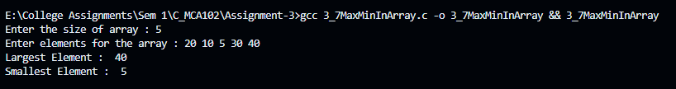

8. Write a program for deleting duplicate elements in an array.

**Answer:**

#include<stdio.h>

void deleteElement (int arr[], int **n, int pos){

  int temp = **n;

  for(int i = pos; i < temp; i++){

    arr[i] = arr[i + 1];

  }

  temp--;

  **n = temp;

}

void deleteDuplicate(int arr[], int *n){

  int temp = *n;

  for(int i = 0; i < temp; i++){

    for(int j = i + 1; j < temp; j++){

      if(arr[i] == arr[j]) deleteElement(arr, &n, j);

    }

  }

}

int main(){

  int n;

  printf("Enter the size of array : ");

  scanf("%d", &n);

  int arr[n];

  printf("Enter elements for the array : ");

  for(int i = 0; i < n; i++)

    scanf("%d", &arr[i]);

  deleteDuplicate(arr, &n);

  printf("After Deleting duplicate elements: \n");

  for(int i = 0; i < n; i++) printf("%d   ", arr[i]);

  return 0;

}

**Output:**

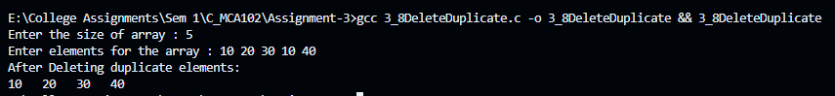

9. Write a program to search for a particular element in an array.

**Answer:**

#include<stdio.h>

int searching (int arr[], int n, int el){

  for(int i = 0; i < n; i++){

    if(arr[i] == el) return i;

  }

  return -1;

}

int main(){

  int n, element;

  printf("Enter the size of array : ");

  scanf("%d", &n);

  int arr[n];

  printf("Enter elements for the array : ");

  for(int i = 0; i < n; i++)

    scanf("%d", &arr[i]);

  printf("Enter the element you want to search : ");

  scanf("%d", &element);

  printf("Index of required element is at: %d", searching(arr, n, element));

  return 0;

}

**Output:**

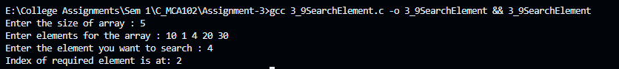

10. Write a program to sort n elements (ascending order).

**Answer:**

#include <stdio.h>

void bubbleSort(int array[], int n) {

    int i, j, temp;

    for (i = 0; i < n - 1; i++) {

        for (j = 0; j < n - i - 1; j++) {

            if (array[j] > array[j + 1]) {

                // Swap the elements

                temp = array[j];

                array[j] = array[j + 1];

                array[j + 1] = temp;

            }

        }

    }

}

int main() {

    int n, i;

    printf("Enter the number of elements: ");

    scanf("%d", &n);

    int array[n];

    printf("Enter the elements:\n");

    for (i = 0; i < n; i++) {

        scanf("%d", &array[i]);

    }

    bubbleSort(array, n);

    printf("Sorted array in ascending order:\n");

    for (i = 0; i < n; i++) {

        printf("%d ", array[i]);

    }

    return 0;

}

**Output:**

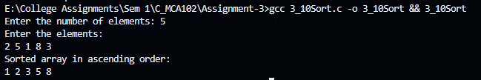

11. Write a program to find second second-highest number from the array without using sorting.

**Answer:**

#include<stdio.h>

#include<limits.h>

int print2ndHighest (int arr[], int size){

  int max = INT_MIN;

  int sl = INT_MIN;

  for(int i = 0; i < size; i++){

      if(max<arr[i]){

          sl = max;

          max = arr[i];

      }

      else if(sl<arr[i] && arr[i]!=max) sl = arr[i];

  }

  return sl;

}

int main(){

  int n;

  printf("Enter the size of array : ");

  scanf("%d", &n);

  int arr[n];

  printf("Enter elements for the array : ");

  for(int i = 0; i < n; i++)

    scanf("%d", &arr[i]);

  printf("Second highest number is : %d", print2ndHighest(arr, n));

  return 0;

}

**Output:**



12. Write a program to perform addition and subtraction between two matrices.

**Answer:**

#include<stdio.h>

int main(){

  int n;

  printf("Enter number of rows / columns : ");

  scanf("%d", &n);

  int arr[n][n], brr[n][n] , add[n][n], sub[n][n];

  printf("Enter elements for first array : \n");

  for(int i = 0; i < n; i++)

    for(int j = 0; j < n; j++)

      scanf("%d", &arr[i][j]);

  printf("Enter elements for second array : \n");

  for(int i = 0; i < n; i++)

    for(int j = 0; j < n; j++)

      scanf("%d", &brr[i][j]);

  for(int i = 0; i < n; i++)

    for(int j = 0; j < n; j++)

      add[i][j] = arr[i][j] + brr[i][j];

  for(int i = 0; i < n; i++)

    for(int j = 0; j < n; j++)

      sub[i][j] = arr[i][j] - brr[i][j];

  printf("Result after Addition : \n");

  for(int i = 0; i < n; i++){

    for(int j = 0; j < n; j++)

      printf("%d   ", add[i][j]);

    printf("\n");

  }

  printf("\n\nResult after Subtraction  : \n");

  for(int i = 0; i < n; i++){

    for(int j = 0; j < n; j++)

      printf("%d   ", sub[i][j]);

    printf("\n");

  }

  return 0;

}

**Output:**

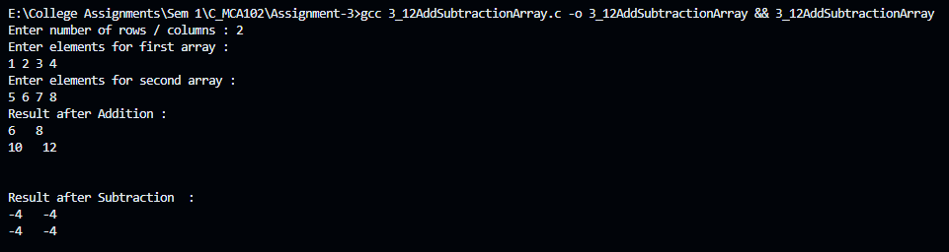

13. Write a program to transpose a matrix.

**Answer:**

#include<stdio.h>

int main(){

  int r, c;

  printf("Enter number of row : ");

  scanf("%d", &r);

  printf("Enter number of column : ");

  scanf("%d", &c);

  int arr[r][c];

  printf("Enter elements for array : \n");

  for(int i = 0; i < r; i++)

    for(int j = 0; j < c; j++)

      scanf("%d", &arr[i][j]);

  printf("\nTranspose: \n");

  for(int i = 0; i < c; i++){

    for(int j = 0; j < r; j++) printf("%d   ", arr[j][i]);

    printf("\n");

}

  return 0;

}

**Output:**

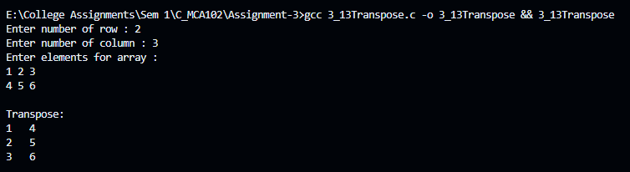

14. Write a program to add the elements of each row and each column of a matrix.

**Answer:**

#include<stdio.h>

int main(){

  int r, c, sum = 0;

  printf("Enter number of row : ");

  scanf("%d", &r);

  printf("Enter number of column : ");

  scanf("%d", &c);

  int arr[r][c];

  printf("Enter elements for array : \n");

  for(int i = 0; i < r; i++)

    for(int j = 0; j < c; j++)

      scanf("%d", &arr[i][j]);

  for(int i = 0; i < r; i++)

    for(int j = 0; j < c; j++)

      sum += arr[i][j];

  printf("Answer : %d", sum);

  return 0;

}

**Output:**

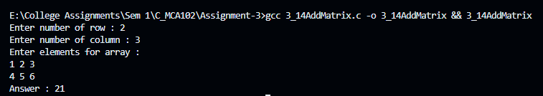

15. Write a program to perform the multiplication of two matrices.

**Answer:**

#include<stdio.h>

int main(){

  int r1 , c1 , r2 , c2;

  printf("Enter values for the First Matrix : \n");

  printf("Enter number of rows : ");

  scanf("%d", &r1);

  printf("Enter number of columns : ");

  scanf("%d",&c1);

  int arr1[r1][c1];

  printf("Enter Elements of First array :\n");

  for(int i = 0; i < r1; i++)

    for(int j = 0; j < c1; j++)

      scanf("%d", &arr1[i][j]);

  printf("\nEnter values for the Second Matrix : \n");

  printf("Enter number of rows : ");

  scanf("%d", &r2);

  printf("Enter number of columns : ");

  scanf("%d",&c2);

  if(c1 != r2) {

    printf("Given Two matrices can't be multiplied.");

    return 0;

  }

  int arr2[r2][c2], ans[r1][c2];

  printf("Enter Elements of Second array :\n");

  for(int i = 0; i < r2; i++)

    for(int j = 0; j < c2; j++)

      scanf("%d", &arr2[i][j]);

  for(int i = 0; i < r1; i++)

    for(int j = 0; j < c2; j++)

      ans[i][j] = 0;

  for(int i = 0; i < r1; i++)

    for(int j = 0; j < c2; j++)

      for(int k = 0; k<c1; k++)

        ans[i][j] += arr1[i][k] * arr2[k][j];

  printf("\nAnswer : \n");

  for(int i = 0; i < r1; i++){

    for(int j = 0; j < c2; j++)

      printf("%d  ", ans[i][j]);

    printf("\n");

  }

  return 0;

}

**Output:**

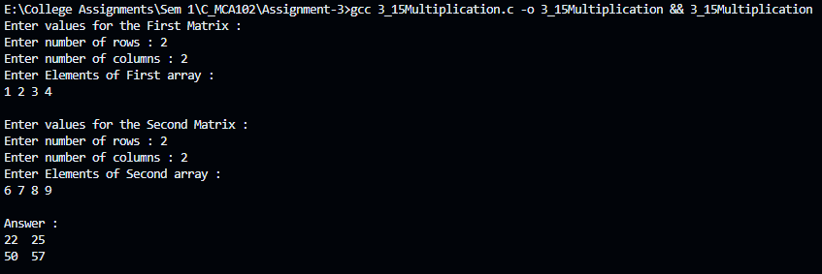

16. Write a program to check whether a matrix is an identity matrix or not.

**Answer:**

#include<stdio.h>

int main(){

  int r, check = 0;

  printf("Enter number of row : ");

  scanf("%d", &r);

  int arr[r][r];

  printf("Enter elements for array : \n");

  for(int i = 0; i < r; i++)

    for(int j = 0; j < r; j++)

      scanf("%d", &arr[i][j]);

  for(int i = 0; i < r; i++){

    for(int j = 0; j < r; j++){

      if((i == j && arr[i][j] != 1) || (i != j && arr[i][j] != 0)) {

        check++;

        break;

      }

    }

    if(check) break;

  }

  if(check) printf("Given Matrix is not Identity Matrix");

  else printf("Given Matrix is Identity Matrix");

  return 0;

}

**Output:**

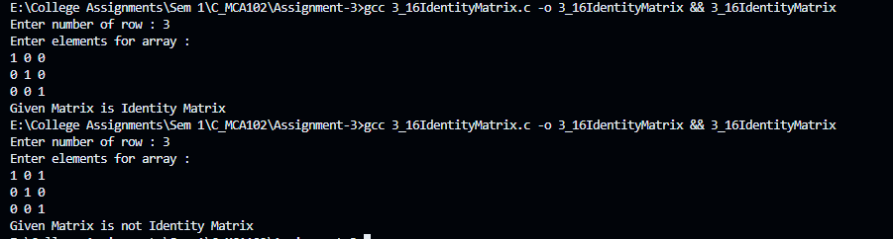

17. Write a program to check whether a matrix is a sparse matrix or not

**Answer:**

#include<stdio.h>

int main(){

  int r, c, zeroCount = 0, count = 0;

  printf("Enter number of row : ");

  scanf("%d", &r);

  printf("Enter number of column : ");

  scanf("%d", &c);

  int arr[r][c];

  printf("Enter elements for array : \n");

  for(int i = 0; i < r; i++)

    for(int j = 0; j < c; j++)

      scanf("%d", &arr[i][j]);

  for(int i = 0; i < r; i++)

    for(int j = 0; j < c; j++){

      if(arr[i][j] == 0) zeroCount++;

      else count++;

    }

  if(zeroCount > count) printf("Given Matrix is Sparse Matrix");

  else printf("Given Matrix is not Sparse Matrix");

  return 0;

}

**Output:**

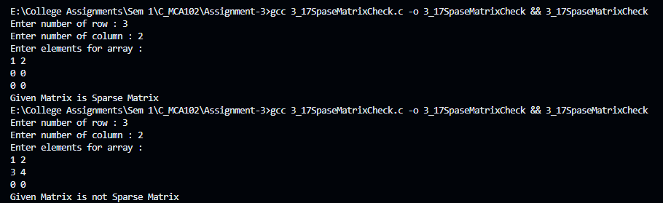

18. Write a C program to create a structure named company which has name, address, phone and no Of Employee as member variables. Read the name of the company, its address, phone and no Of Employee. Finally display these members‟ values.

**Answer:**

#include<stdio.h>

#include<string.h>

  struct company{

    char name[50];

    char address[100];

    int phone;

    int noOfEmployee;

  };

int main(){

  struct company c;

  printf("Enter the company name: ");

  fgets(c.name, sizeof(c.name), stdin);

  printf("Enter the company address: ");

  fgets(c.address, sizeof(c.address), stdin);

  printf("Enter the company phone number: ");

  scanf("%d", &c.phone);

  printf("Enter the number of employees: ");

  scanf("%d", &c.noOfEmployee);

  printf("\nCompany Details:\n");

  printf("Name: %s", c.name);

  printf("Address: %s", c.address);

  printf("Phone: %d\n", c.phone);

  printf("Number of Employees: %d\n", c.noOfEmployee);

  return 0;

}

**Output:**

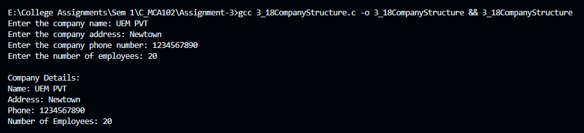

19. Define a structure “complex” (typedef) to read two complex numbers and perform addition, and subtraction of these two complex numbers and display the result.

**Answer:**

#include<stdio.h>

#include<string.h>

  typedef struct complex{

    float real;

    float imag;

  } complex;

complex add(complex c1, complex c2) {

  complex result;

  result.real = c1.real + c2.real;

  result.imag = c1.imag + c2.imag;

  return result;

}

complex subtract(complex c1, complex c2) {

  complex result;

  result.real = c1.real - c2.real;

  result.imag = c1.imag - c2.imag;

  return result;

}

int main(){

  complex c1, c2, sum, diff;

  printf("Enter the real and imaginary part of the first complex number:\n");

  scanf("%f %f", &c1.real, &c1.imag);

  printf("Enter the real and imaginary part of the second complex number:\n");

  scanf("%f %f", &c2.real, &c2.imag);

  sum = add(c1, c2);

  diff = subtract(c1, c2);

  printf("\nResult of Addition: %.2f + %.2fi\n", sum.real, sum.imag);

  printf("Result of Subtraction: %.2f + %.2fi\n", diff.real, diff.imag);

  return 0;

}

**Output:**

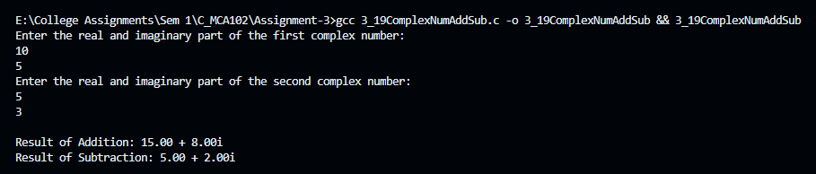

20. Write a C program to read the Roll No, Name, Address, and Age marks of 12 students in the BCT class and display the details from the function.

**Answer:**

#include <stdio.h>

struct student {

    int rollNo;

    char name[50];

    char address[100];

    int age;

    float marks;

};

// Function to display student details

void displayDetails(struct student s[], int n) {

    printf("\nStudent Details:\n");

    for (int i = 0; i < n; i++) {

        printf("\nStudent %d:\n", i + 1);

        printf("Roll No: %d\n", s[i].rollNo);

        printf("Name: %s", s[i].name);

        printf("Address: %s", s[i].address);

        printf("Age: %d\n", s[i].age);

        printf("Marks: %.2f\n", s[i].marks);

    }

}

int main() {

    struct student bctClass[12];

    // Reading details of 12 students

    for (int i = 0; i < 12; i++) {

        printf("Enter details of student %d:\n", i + 1);

        printf("Roll No: ");

        scanf("%d", &bctClass[i].rollNo);

        getchar();  // To consume the newline character after entering Roll No

        printf("Name: ");

        fgets(bctClass[i].name, sizeof(bctClass[i].name), stdin);

        printf("Address: ");

        fgets(bctClass[i].address, sizeof(bctClass[i].address), stdin);

        printf("Age: ");

        scanf("%d", &bctClass[i].age);

        printf("Marks: ");

        scanf("%f", &bctClass[i].marks);

        getchar();  // To consume the newline character after entering marks

        printf("\n");

    }

    // Displaying student details

    displayDetails(bctClass, 12);

    return 0;

}

**Output:**

